**Discrete Structures**

**Assignment # 1 (Solution)**

**Program:** BS(SE), BS(CS)

**Question 1:**

1. 2+3 = 5. Yes
2. 4 + x = 5. No
3. There is no pollution in Pakistan. No
4. The moon is made of green cheese. Yes
5. 2n ≥ 100. No
6. Answer this question. No

**Question 2 :** When I stay late, it is necessary that I sleep until noon.

1. Inverse: If it doesn’t snow today. I will not ski tomorrow.

Converse: If I will ski tomorrow, then it snows today.

Contrapositive: If I will not ski tomorrow, then it doesn’t snow today.

Implication Law: It doesn’t snow today OR I will ski tomorrow

1. Inverse: If there is not going to be a quiz then I will not come to class.

Converse: If I come to class then there is going to be a quiz.

Contrapositive: If I will not come to class then there is not going to be a quiz.

Implication Law: If I will not come to class OR there is going to be a quiz.

1. Inverse: If it is not a sunny summer day then I will not go to the beach

Converse: If It is a sunny summer day then I go to the beach whenever.

Contrapositive: If It is not a sunny summer day then I will not go to the beach whenever.

Implication Law: It is not a sunny summer day OR I go to the beach whenever.

1. Inverse: If I stay late then I will sleep until noon.

Converse: If I will sleep until noon then I stay late.

Contrapositive: If I will not stay late then I will not sleep until noon.

Implication Law: I don’t stay late OR I will sleep until noon

**Question 3 :**

1. I don’t buy a lottery ticket.
2. If I don’t buy a lottery ticket then I will not win the million-dollar jackpot on Friday.
3. I bought a lottery ticket iff I won the million-dollar jackpot on Friday
4. I don’t buy a lottery ticket OR I bought a lottery ticket and I won the million dollar jackpot on Friday.

**Question 4 :**

1. P🡪q
2. ~p🡪~q
3. q^~p
4. p🡪q

**Question 5:**

1. solution:

(s🡪 r) ∧ (q🡪r) L.H.S

**≡** (~ s v r) ∧ (~q v r) Implication law

**≡** (~s ∧ ~q) v r Inverse distributive law

**≡** ~ (s v q) v r Inverse Demorgan’s law

**≡** (s v q)🡪r R.H.S Inverse implication law

b) Solution:

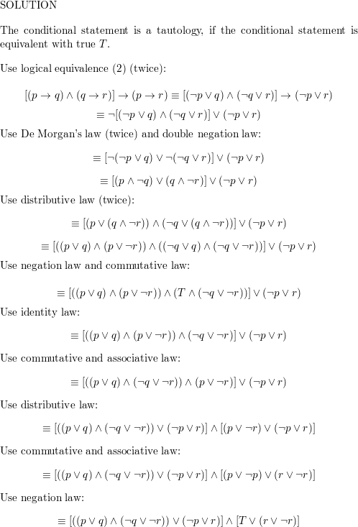

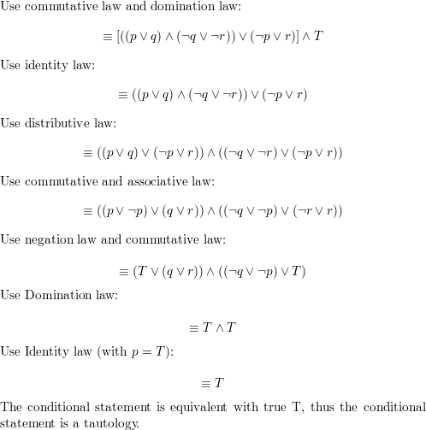

c)  
solution:

